

**INDIVIDUAL PROJECT: A PATIENT ASSISTANT NETWORK DATABASE SYSTEM**

**COURSE: CS/DSA-4513**

**DATABASE MANAGEMENT SECTION: 001**

**SEMESTER: FALL 2024**

**INSTRUCTOR: DR. LE GRUENWALD**

Paulina Castillo

Sooner ID 113621903

paulina.castillo@ou.edu

SCORE:

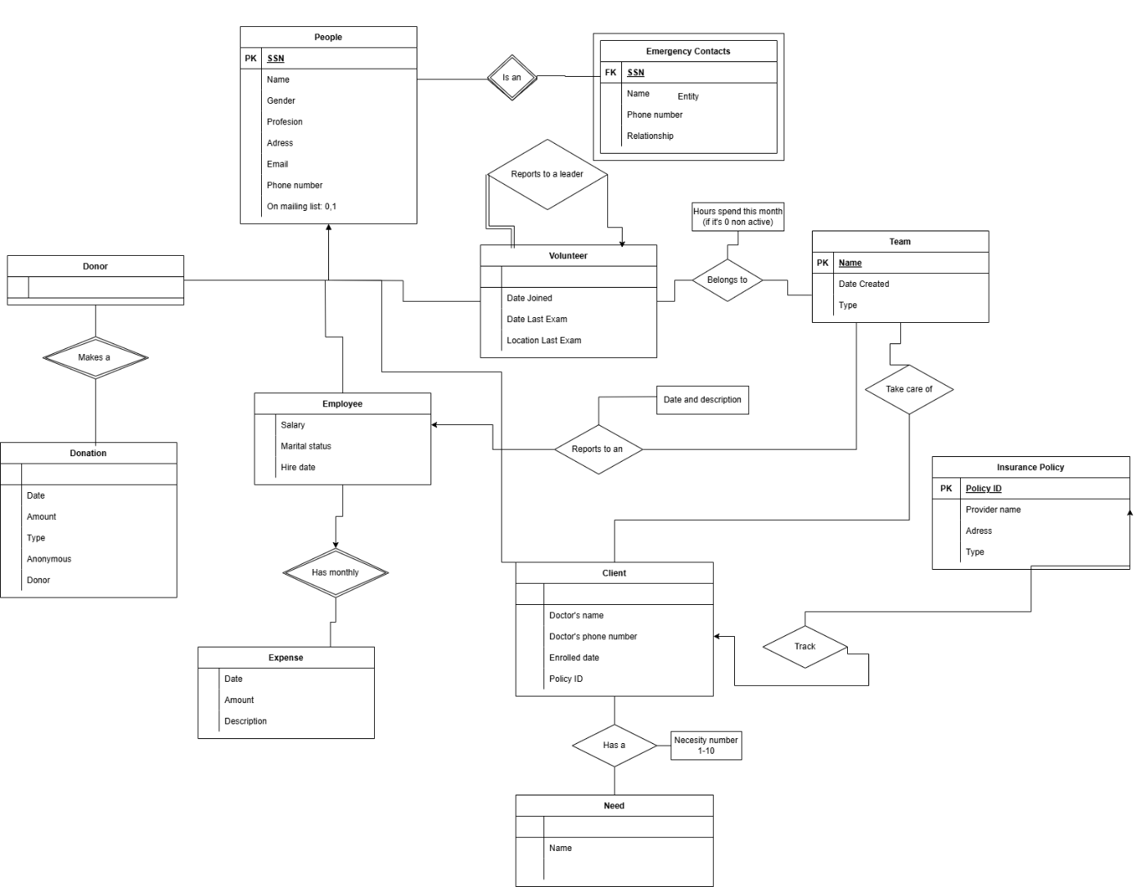

2.

People(

SSN (Primary Key),

Name,

Gender,

Profession,

Address,

Email,

PhoneNumber,

MailingList (Boolean)

)

EmergencyContacts(

SSN (Foreign Key ),

Name,

PhoneNumber,

Relationship

)

Donor(

SSN (Foreign key),

)

Donation(

DonationID (Primary Key),

SSN (Foreign Key to Donor),

Date,

Amount,

Type,

IsAnonymous (Boolean),

FundraisingCampaign,

CheckNumber (Nullable),

CardNumber (Nullable),

CardType (Nullable),

ExpirationDate (Nullable)

)

Employee(

SSN (Foreign Key ),

Salary,

MaritalStatus,

HireDate,)

Expense(

Date,

Amount,

Description

)

Volunteer(

SSN (Foreign Key ),

DateJoined,

MostRecentTrainingDate,

MostRecentTrainingLocation,

)

Team(

Name(Primary Key),,

Type,

CreationDate

TeamLeader(SNN Foreign Key)

)

Client(

SSN (Foreign Key ),

DoctorName,

DoctorPhoneNumber,

EnrroledDate,)

Need(

Name,

)

InsurancePolicy(

PolicyID (Primary Key),

ClientSSN (Foreign Key),

ProviderName,

ProviderAddress,

Type (life, health, home, auto)

)